**塔石街道执法程序**

[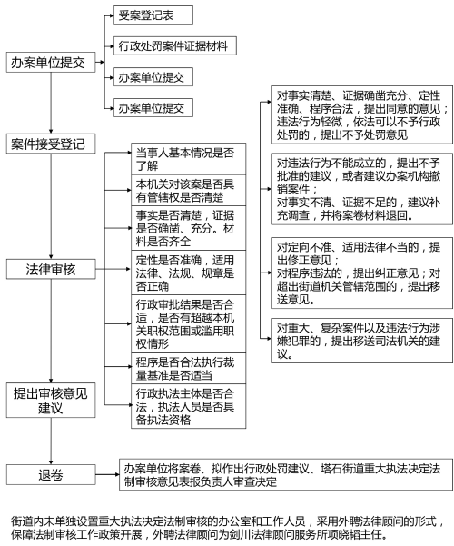](http://zjjcmspublic.oss-cn-hangzhou-zwynet-d01-a.internet.cloud.zj.gov.cn/jcms_files/jcms1/web3722/site/picture/0/2a04743d312c469e81925f1d97162496.png)